Building levels for Lol-ball

Getting the editor
The editor is a free 3d-editing program called anim8or. It can be downloaded from www.anim8or.com. The latest version, which I use, is the 0.95. Older (and newer) versions should world without to many problems. This document assumes you are familiar with the anim8or controls, if in doubt how to do something, consult the anim8or manual.
When moving objects I find it easier to enable grid snap (Options->Grid). The settings below works for me.
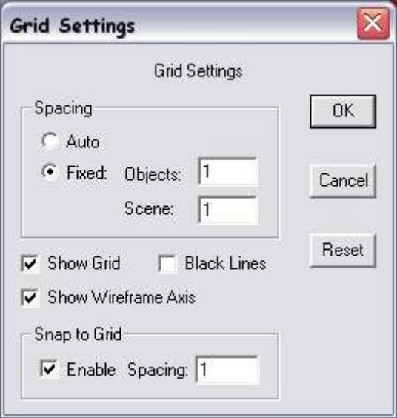

Making the levels
- Open worldobjects/levels.an8 and enter scene mode
- Each level is it own scene and will get a file name equal to its scene name once it is converted.
- The world is completely built with objects, so add objects with build->add object and use the tools to move and rotate the objects. While scale works in anim8or it doesn’t in lolball, so please don’t use that.
- Object that begins with an underscore is considered an entity. Objects that doesn’t, is only part of the collision, rendering or both.
- When the level is done, save it and run build_levels.bat to build all the level files.
- Each level file is really an xml file with a lvl extension, and if needed it is easy to open it in a text editor and change the variables that need changing.

Below is a list of entities that exist in the lol-boll game. The only object that isn’t in that list, but one that needs some explanation is the sky sphere object.

There can be only one sky sphere, and if you try to add more than one it will probably look strange. The name of the sky sphere results in which type of sky. Currently the only sky available is sky.

Entity | Description
_LevelName | The text that pops up at the beginning of each level. Should have the style of something like Level 04: Fall of death, that is Level two-digit-number: Level title, but it’s your decision.
_NextLevel | The next level to come when you completed this one, without extension.
_start | The start position and rotation of the lol-ball.
_GameOverPlane | The height at which the death/game over plane is placed. The other values are ignored.
_end | The goal position.
_2_box_0.5_0.5_0.5_cube | Represents a basic wooden box that the lol-ball easily can move.  First digit tells its density. The box says it should be physically represented as a box (the only one supported at this moment), the following 3 numbers tell about the box size. The last says which model to use.

